Soen 341 Final Report

**Questions and Answers Website Release Summary** **3**

**Project Summary** **4**

**User Stories** **4**

# Questions and Answers Website Release Summary

Team Members

| Abhinav Batra 40086809  Eyad Al Sweidan 40068386  Laila Alhalabi 40106558  Zeneib Ben Mami 40024877  Hristo Marinov 40156820  Simren Matharoo 40042587  Stirling Smith 40043828  Matthew Williams 40129305 | AbhB2303  Eyadsw  Lailaalhalabi  Zeinebbenmami  Hmarinov10  Simrenmatharoo  Stirl2608  matthew-williams1 |  |
| --- | --- | --- |
|  |  |  |

# Project Summary

For our project, we wanted to keep in mind the user. Freedom of speech is very important for us as a species so we made a website to post all your questions and have anyone respond. We, as a team, wanted to bring people together and allow for everyone to learn from each other by asking all these questions and everyone giving unique feedback for everyone's burning questions. Sometimes, sites such as these will delete questions that are left after a few months but with our database, we will be able to keep all these questions for years to come so that people from all generations can come and see if the questions they want to ask have already been asked. That is why, we have made AskAway.net and starting today, you can sign up and ask away.

# User Stories

Total: 41 Stories, ___ Points over ___ Weeks

Sprint 1: (4 Stories)

US #1: Product Description [No Points [Status: Done]

US #2: Creating Sub User Stories [No Points] [Status: Done]

US #3: Update Meeting Minutes [No Points] [Status: Done]

US #4: Delete Meeting Minutes File [No Points] [Status: Done]

Sprint 2: (15 Stories)

US #1: Answering Questions [12 Points] [Status: Done]

US #2: New Page Creation for Answering Questions [1 Point] [Status: Done]

US #3: Include Image Integration in Asking Questions Textbox [3 Points] [Status: Done]

US #4: Cancel Button added to Asking Questions Page [No Points] [Status: Done]

US #5: Create Footer [2 Points] [Status: Done]

US #6: Create Menu Bar [2 Points] [Status: Done]

US #7: Cancel Question Button [1 Points] [Status: Done]

US #8: Travis CI Failing All Tests [No Points] [Status: Done]

US #9: Can’t Compile Asking Questions form Pull Requests re issue [No Points] [Status: Done]

US #10: Create Text Box in the Asking Questions Page [1 Point] [Status: Done]

US #11: New Page Creation for Asking Questions[1 Point] [Status: Done]

US #12: Submit Button on Asking Questions [1 Point] [Status: Done]

US #13: Setup Travis CI [2 Points] [Status: Done]

US #14: Added Needed Libraries [No Points] [Status: Done]

US #15: Answering Questions [No Points] [Status: Done]

Sprint 3 (15 Stories)

US #1: Asking Questions [12 Points] [Status: Done]

US #2: Send User to Answering Questions page when Submit button on Asking questions page is pressed [1 Point] [Status: Done]

US #3: Acceptance tests for all stories [No Points] [Status: Done]

US #4: Cannot Compile main branch [No Points] [Status: Done]

US #5: Bug fixes in app [No Points] [Status: Done]

US #6: Navigating questions [7 Points] [Status: Done]

US #7: Save content of textbox to the SQL server when submit button is pressed [4 Points] [Status: Done]

US #8: Include relevant libraries [1 Point] [Status: Done]

US #9: Create SpringBoot backend application [1 Point] [Status: Done]

US #10: Voting on the Answers [10 Points] [Status: ]

US #11: Vote count [3 Points] [Status:]

US #12: Downvote answer [2 Points] [Status:]

US #13: Upvote answer [2 Points] [Status:]

US #14: User login [3 Points] [Status:]

US #15: Block diagram [No Points] [Status: Done]

Sprint 4 (8 Stories)

US #1: Create Display boxes for previous questions and answers [2 Points] [Status:]

US #2: Extra feature: User Profile Page [10 Points] [Status: ]

US #3: Notifications [5 Points] [Status: ]

US #4: Pinning the top answer [4 Points] [Status: ]

US #5: Accepting the best answer [4 Points] [Status: ]

US #6: Create new page for user profile [1 Points] [Status: ]

US #7: Implement the backend connectivity of the display boxes for the user profile page [8 Points] [Status: ]

US #8: Extra feature: User profile pages [15 Points] [Status: ]

# Overall Arch and Design

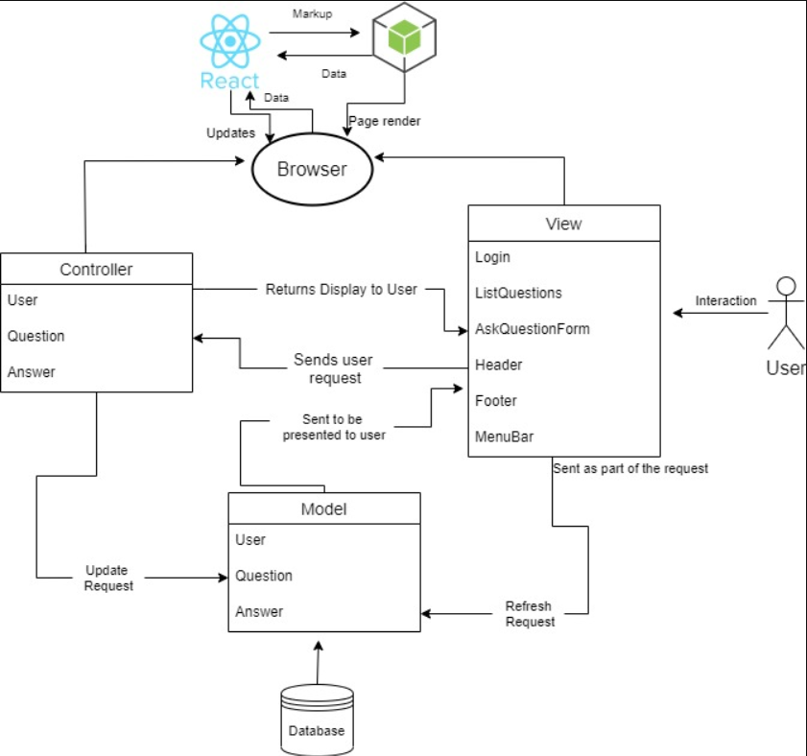

Block diagram of the system